Turnaround Times
- Trafficking an Ordered Line Item – 3 Business Days
- E-Mail Count Request - 2 Business Days
- Inventory/Forecast Requests – 1 Business Day
- Changes to an existing ticket - 1 Business Day
- Custom Solo Emails – 3 Business Days
- Pixel Request - 1 Business Day
- Creative Swap - 1 Business Day
- SEO Proposal Request - 2 Business Days
- Proposal Requests – 5 business days
If a problem is found with a request such as missing information or assets, the count-down clock stops and will only resume once all information is received or issues are resolved.
Below is a chart showing an example of 3 business day processing timelines:
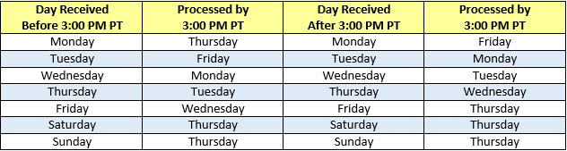
Example: If an order is received at 4:00 PM PT on Tuesday that order will be treated as if it were received on Wednesday.
Campaign Changes / Optimizations
- Optimization Requests from the requester will be trafficked within 1 business day.
  - Please note that the campaign will need to go through the DFP approval process again if changes or optimizations have been made.
- Optimizations recommended by the Ntooitive team must be approved by the requester and client unless otherwise stated.
- If a campaign doesn’t go live within 7 business days of the start date the buy sheet needs to be revised to reflect the new start date.

Urgents
Orders are considered Urgent if they are submitted with a start date within the 2 business day turnaround. Urgents will be addressed on a first come first serve basis and will be processed as soon as possible. Urgent orders may be subject to approval based on the content and context of the order. If an Urgent order is rejected the affected Sales Manager will be notified.
Reporting Expectations
All campaigns will receive a final report. Multi-Month Campaigns will receive a mid-month and end of month report in addition to a final report. All campaigns are eligible for Ad Hoc Reporting. Month End Reporting will be provided within the first 5 business days of the month. Campaigns that run a calendar month or more will receive a mid-month report within the first 3 days of the 3rd business week.

Example: A campaign scheduled with a start of August 1st through the 31st would receive reporting on the 17th, 18th, or 19th (Example from 2015)

Ad Hoc Reporting has a 1 business day turnaround. Ad Hoc Reporting requested during a scheduled reporting period will be completed as soon as possible. The 1 day turnaround does not apply during this timeframe. E-mail reporting cannot be requested within 5 business days of the send.

